0000.doc




SAMPLE EXAMINATION

MODERN HISTORY DOCUMENT BOOKLET
Stage 3

CONTENTS:

Document set | Area of study | Number of sources | Related question
1 | Australia (1880s–1920s) | 7 | 1
2 | Australia (1920s–1950s) | 7 | 1
3 | Australia (1950s–1990s) | 7 | 1
4 | Ideas that shaped the Russian Revolution | 2 | 5
5 | Ideas that shaped the Chinese Revolution | 2 | 5
6 | Ideas that shaped the Cold War in Europe | 2 | 5
7 | Ideas that shaped conflict in the Middle East | 2 | 5

SECTION ONE: DOCUMENT STUDY—Unit 3A
DOCUMENT SET 1
Australia 1880s–1920

Source 1
(The following extracts are from letters and diaries of soldiers serving on the Western Front in the First World War.)

Soldier (a)
... a shocking bombardment, hell let loose ... it seems as though every gun the enemy possessed was ranged against us ... the Germans set up a cheering and shouting, the like, I have never heard before and simultaneously charged us in mass formation ... It was fearful yet awe-inspiring, for the first few minutes I felt sick, then as steady as a rock, I was right in the line of fire and the shells came straight for my bay... some fellows nerves gave way and they became gibbering idiots, Sergeants and all sorts, god it was little wonder for... fighting here is just simply massacre.

Soldier (b)
... one foggy morning ... we could hear someone over towards the German entanglements calling for a stretcher bearer; it was an appeal no man could stand against; so some of us rushed out and had a hunt; we found a fine haul of wounded and brought them in ... another man about 30 yes [yards] out sang out 'Don't forget me cobber', I went in and got four volunteers with stretchers and we got [him and another man] in safely.

Source 2
(This painting titled The beach at Anzac by F. Crozier was created in 1919 and is part of the collection of The Australian War Memorial In Canberra.)
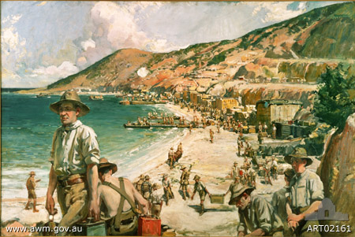

DOCUMENT SET 1
Australia 1880s–1920s continued

Source 3
(In this cartoon, produced late in 1916 by a regular contributor to the Daily Worker, Prime Minister Hughes is holding a circular bomb in his hand. The fuse is burning and its smoke spells out ‘Conscription’.)
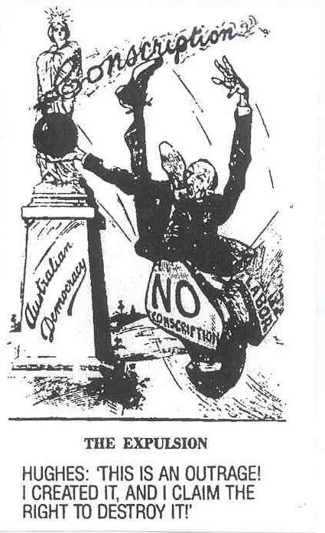

Source 4
(A photograph of Prime Minister William Hughes in London at the end of the war.)
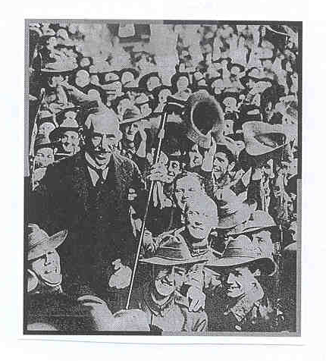
DOCUMENT SET 1
Australia 1880s–1920s continued

Source 5

Changes in Australian prices July 1914 to 1919
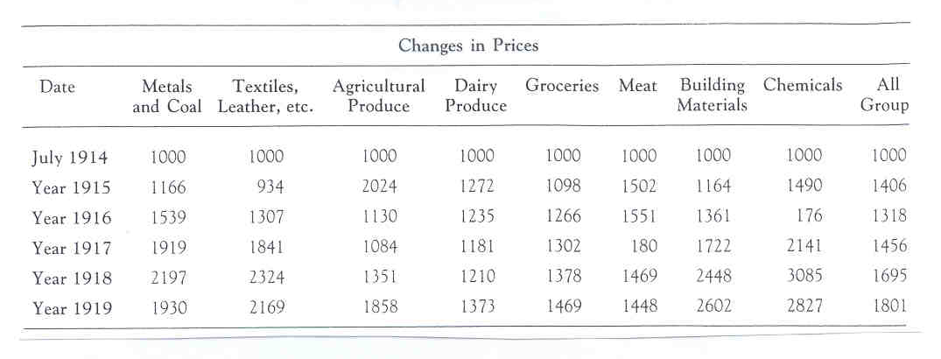

DOCUMENT SET 1
Australia 1880s–1920s continued

Source 6
(The following extract was published in The West Australian on 25 April 1996.)

Anzac legend unites generations
Their numbers are dwindling but their immortal spirit continues to inspire a nation. ...
In past years, it would have been almost unthinkable to commemorate Anzac Day in the absence of the men whose exploits far from home created the legend that it celebrates. But such is the power of their story and their sacrifice that Australians will continue to honour them long after the last Gallipoli veteran has gone. ...
Other wars have spilt Australian blood and tested the mettle of our fighting men and women, who have not been found wanting. They too have earned the honour and gratitude with which their feats are remembered on Anzac Day by living up to the noble traditions that was forged by the Anzacs.
Although memories of Australian sacrifices in other wars are more recent ... it is the Gallipoli legend that gives the Day its special spiritual significance for Australians. By their growing participation in Anzac Day ceremonies, young people have shown that Gallipoli is more to them than a name in a history book or atlas ─ and their understanding of and feeling for the legend will ensure its continuation across generations to come.
In the years to come more attention inevitably will shift to veterans of later conflicts ─ including World War II, Korea and Vietnam... Their stories will still be told ... while those of the original Anzacs will be a legend held in the collective memory of the nation.

Source 7

(The following extract from Gallipoli: The Fatal Shore was written in 2005 by Harvey Broadbent, who has been a documentary producer with the Australian Broadcasting Corporation and Senior Research Fellow in the Department of Modern History at Macquarie University.)

... The nature of the Anzac Day commemorations itself has had its share of controversy in recent years ...
The mythical place of Anzac in the affairs of state has been elevated even more in recent times, affording additional opportunities for politicians to associate themselves with the Anzac kudos*...
At the end of 2003, seemingly to mark the re-endorsement of Anzac and its central importance to Australia as a foundation myth, Australian Prime Minister John Howard made a momentous pronouncement, broadcast on television and radio news programs. Standing at a lectern in front of images of Anzac Cove, he announced the creation of a $52.6 million program designed to identify, protect and manage sites of national significance to be included on a National Heritage List. He proposed the Anzac as 'a fitting first nomination . . . given its significance in shaping the identity of our nation'. He continued: 'The soil there is as much part of Australia as the earth on which their home is built'. The statement was a dramatic endorsement of Gallipoli's potency**.

* kudos = glory or renown
** potency = power or might
DOCUMENT SET 2
Australia 1920s to 1950s

Source 1
(The following are comments by Australians who were involved in the Second World War.)

Reg Saunders remembers last days of the battle of Crete.

For copyright reasons this text cannot be reproduced in the
online version of this document.
For two days, we ate no food of any kind... for the last couple days we were without water ― and the result was that we just couldn’t eat. At times, we were almost running to keep up with the battalion. Every one of us knew that it was a race against time ... and that anyone who stopped had had it.

Hilda Lumsden remembers nursing in New Guinea.

I always remember early [19]43 getting the boys off the Kokoda Trail, you know who had been in their clothes for ages and some of their boots had just rotted off. It was like heaven for them to get washed and cleaned and put into bed. But always these big heavy boots encrusted with mud were there as a reminder of what they had been through. ... I think the physical wounds were the worst because our boys were very tough mentally, they really stood up to it wonderfully well, they just wanted to be cured as soon as possible and on their way home.

Source 2
(This painting showing the Kokoda Trail in 1942 and created by G. Browning in 1945 is part of the collection of The Australian War Memorial in Canberra.)

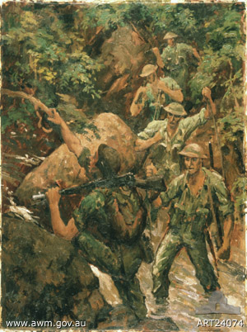

DOCUMENT SET 2
Australia 1920s–1950s continued

Source 3
(This cartoon depicting Prime Minister John Curtin was published in the Bulletin on 6 January 1943. At the time Curtin was addressing the ALP conference in relation to conscripts fighting outside Australian controlled territory.)

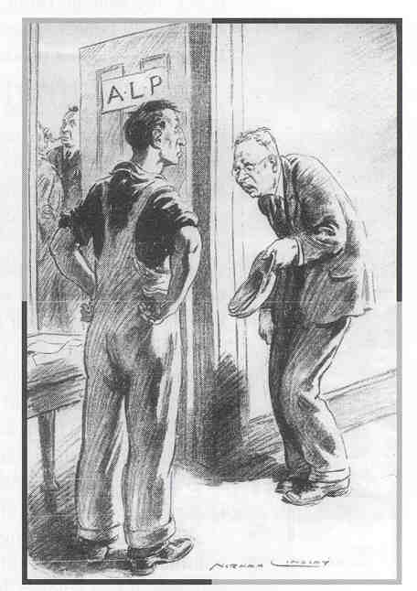
Curtin

Source 4
(A photograph of Prime Minister John Curtin and General MacArthur taken in June 1943.)

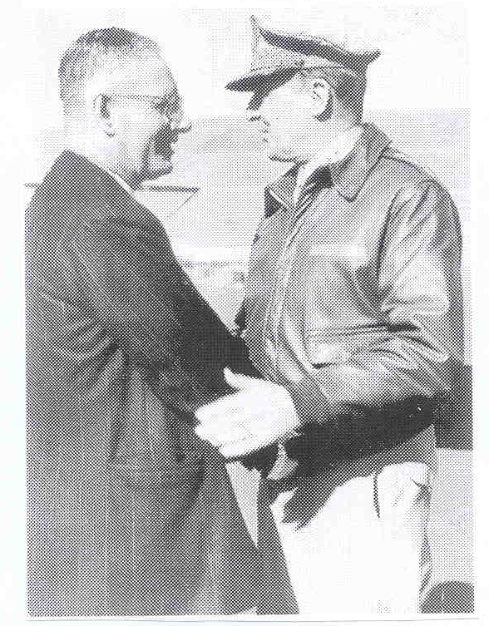

DOCUMENT SET 2
Australia 1920s–1950s continued

Source 5
Men’s and women’s employment 1933 and 1943

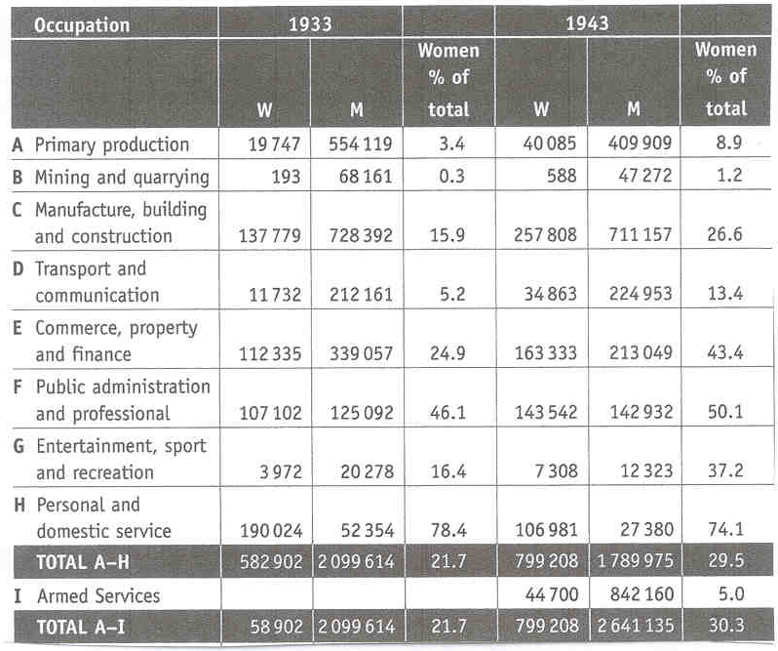

DOCUMENT SET 2
Australia 1920s to 1950s continued

Source 6
(The following extract was published in The West Australian on 25 April 1996.)

Anzac legend unites generations

Their numbers are dwindling but their immortal spirit continues to inspire a nation. ...
In past years, it would have been almost unthinkable to commemorate Anzac Day in the absence of the men whose exploits far from home created the legend that it celebrates. But such is the power of their story and their sacrifice that Australians will continue to honour them long after the last Gallipoli veteran has gone. ...
Other wars have spilt Australian blood and tested the mettle of our fighting men and women, who have not been found wanting. They too have earned the honour and gratitude with which their feats are remembered on Anzac Day by living up to the noble traditions that was forged by the Anzacs.
Although memories of Australian sacrifices in other wars are more recent ... it is the Gallipoli legend that gives the Day its special spiritual significance for Australians. By their growing participation in Anzac Day ceremonies, young people have shown that Gallipoli is more to them than a name in a history book or atlas ─ and their understanding of and feeling for the legend will ensure its continuation across generations to come.
In the years to come more attention inevitably will shift to veterans of later conflicts ─ including World War II, Korea and Vietnam… Their stories will still be told ... while those of the original Anzacs will be a legend held in the collective memory of the nation.

Source 7

(The following extract from Gallipoli: The Fatal Shore was written in 2005 by Harvey Broadbent, who has been documentary producer with the Australian Broadcasting Corporation and Senior Research Fellow in the Department of Modern History at Macquarie University.)

... The nature of the Anzac Day commemorations itself has had its share of controversy in recent years ...
The mythical place of Anzac in the affairs of state has been elevated even more in recent times, affording additional opportunities for politicians to associate themselves with the Anzac kudos*...
At the end of 2003, seemingly to mark the re-endorsement of Anzac and its central importance to Australia as a foundation myth, Australian Prime Minister John Howard made a momentous pronouncement, broadcast on television and radio news programs. Standing at a lectern in front of images of Anzac Cove, he announced the creation of a $52.6 million program designed to identify, protect and manage sites of national significance to be included on a National Heritage List. He proposed the Anzac as 'a fitting first nomination . . . given its significance in shaping the identity of our nation'. He continued: 'The soil there is as much part of Australia as the earth on which their home is built'. The statement was a dramatic endorsement of Gallipoli's potency**.

* kudos = glory or renown
** potency = power or might

DOCUMENT SET 3
Australia 1950s–1990s

Source 1
(The following extracts are comments from soldiers who served in Vietnam.)

Soldier (a)
The forward scout got about half way along [a creek bed] and he just died on the spot, he just crumpled and that was it. We didn’t hear anything, he just crumpled ... A very good friend of mine, he went out to try and fix him up and he only got to the stage where he was bending over him ... [and] he just got shot straight through the heart. Another one of our medics got there and he got shot just straight through the head ... They made me bag them up in green bags and I can still remember my friend’s face. He was smiling.

Soldier (b)
After a while you became accustomed to it ... it was sort of boring, hot humid. You got wet, you got eaten by mosquitoes, the leeches. You were tramping around in water, fighting your way through the bamboo ... I think for the first two months that I was out with the battalion we had not one single contact.

Source 2
(This painting titled Long Tan action, Vietnam, 18 August 1966 and created by B. Fletcher in 1970 is part of the collection of The Australian War Memorial in Canberra.)

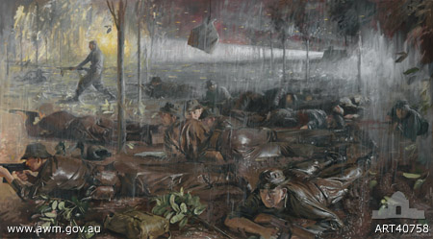
DOCUMENT SET 3:
Australia 1950s–1990s continued

Source 3

(This cartoon was published in The Australian in 1966.)

For copyright reasons this image cannot be reproduced in the online version of this document.
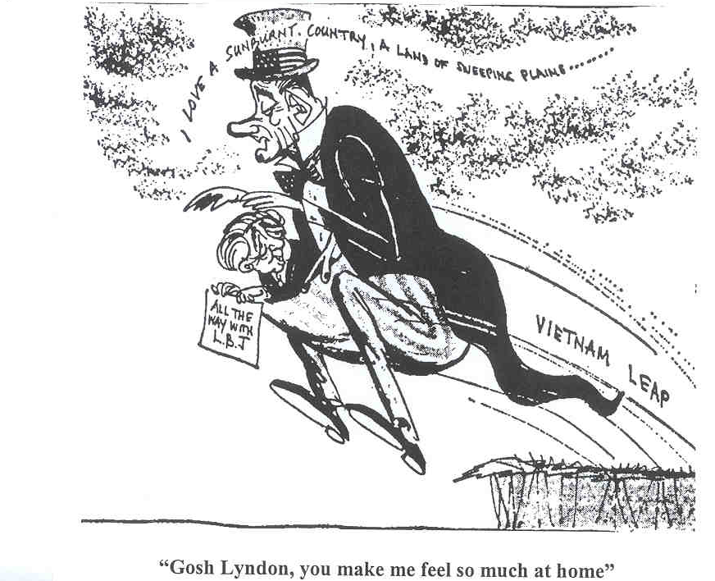

Source 4
(A photograph of President Lyndon Johnson and Prime Minister Harold Holt taken at Canberra airport in 1966.)

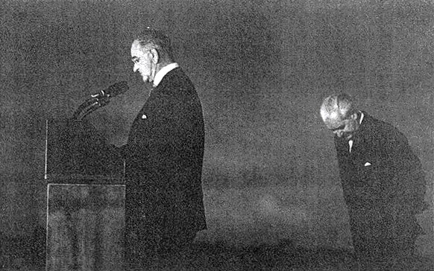
DOCUMENT SET 3:
Australia 1950s–1990s continued

Source 5
The following tables were compiled from figures from a number of public opinion polls between 1965 and 1971.
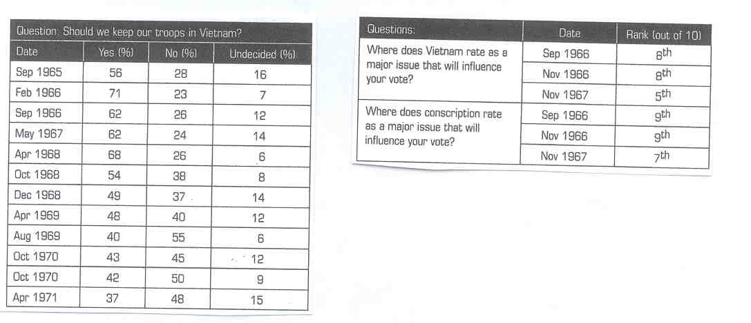

DOCUMENT SET 3:
Australia 1950s–1990s continued

Source 6
(The following extract was published in The West Australian on 25 April 1996.)

Anzac legend unites generations

Their numbers are dwindling but their immortal spirit continues to inspire a nation. ...
In past years, it would have been almost unthinkable to commemorate Anzac Day in the absence of the men whose exploits far from home created the legend that it celebrates. But such is the power of their story and their sacrifice that Australians will continue to honour them long after the last Gallipoli veteran has gone. ...
Other wars have spilt Australian blood and tested the mettle of our fighting men and women, who have not been found wanting. They too have earned the honour and gratitude with which their feats are remembered on Anzac Day by living up to the noble traditions that was forged by the Anzacs.
Although memories of Australian sacrifices in other wars are more recent ... it is the Gallipoli legend that gives the Day its special spiritual significance for Australians. By their growing participation in Anzac Day ceremonies, young people have shown that Gallipoli is more to them than a name in a history book or atlas ─ and their understanding of and feeling for the legend will ensure its continuation across generations to come.
In the years to come more attention inevitably will shift to veterans of later conflicts ─ including World War II, Korea and Vietnam… Their stories will still be told ... while those of the original Anzacs will be a legend held in the collective memory of the nation.

Source 7

(The following extract from Gallipoli: The Fatal Shore was written in 2005 by Harvey Broadbent, who has been documentary producer with the Australian Broadcasting Corporation and Senior Research Fellow in the Department of Modern History at Macquarie University.)

... The nature of the Anzac Day commemorations itself has had its share of controversy in recent years ...
The mythical place of Anzac in the affairs of state has been elevated even more in recent times, affording additional opportunities for politicians to associate themselves with the Anzac kudos*...
At the end of 2003, seemingly to mark the re-endorsement of Anzac and its central importance to Australia as a foundation myth, Australian Prime Minister John Howard made a momentous pronouncement, broadcast on television and radio news programs. Standing at a lectern in front of images of Anzac Cove, he announced the creation of a $52.6 million program designed to identify, protect and manage sites of national significance to be included on a National Heritage List. He proposed the Anzac as 'a fitting first nomination . . . given its significance in shaping the identity of our nation'. He continued: 'The soil there is as much part of Australia as the earth on which their home is built'. The statement was a dramatic endorsement of Gallipoli's potency**.
* kudos = glory or renown
** potency = power or might

THIS PAGE HAS BEEN LEFT BLANK INTENTIONALLY

SECTION THREE: DOCUMENT STUDY—Unit 3B
DOCUMENT SET 4
Ideas that shaped the Russian Revolution 1900s–1940s

Source 1
(A poster published after the death of Lenin. The words at the bottom of the poster translate as V I Ulyanov–Lenin.)

1870-1924
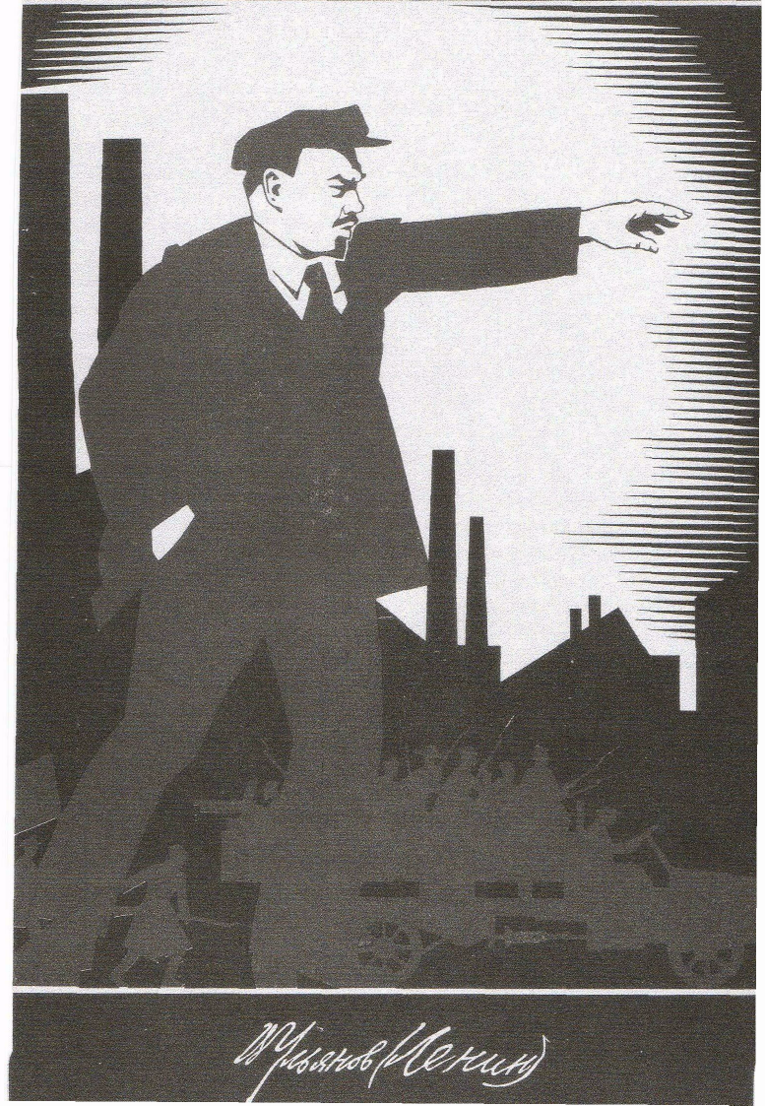

For copyright reasons this image cannot be reproduced in the online version of this document but may be viewed at http://sociology.berkeley.edu/faculty/bonnell/images/lenin_1870.jpg
DOCUMENT SET 4
Ideas that shaped the Russian Revolution 1900s–1940s continued

Source 2
An extract written by historian Richard Pipes and published in 1995.)

For copyright reasons this extract cannot be reproduced in the online version of this document.
Lenin saw himself as the commander-in-chief of a organization committed to permanent political warfare. He unquestionably excelled in this particular pursuit... [Lenin] was never an outstanding statesman — he had few constructive ideas — but that he was one of the great conquerors of world history, a man who vanquished his own country in a way that no one before him had even attempted. The rival parties, the socialists and, to some extent, the liberals, were populist believing in the innate wisdom of the Russian people. They were not prepared to fight, and they lost out to politician for whom struggle was a normal occupation and peace a mere breathing-spell for war.

Lenin wanted power... Lenin's rivals did not want it. ... In 1917, the Socialists-Revolutionaries and the Mensheviks were quite content to let the “bourgeois” Provisional Government govern while they kept up a steady barrage of denunciation and criticism. But Lenin wanted much more. ...

Russia he viewed as nothing more than a stepping-stone to global upheaval; a backward country, populated mainly by an uncouth rural "petty bourgeoisie" in the shape of self-sufficient "middle" peasants and "kulaks." Such a country could not make a world revolution: at best, it could serve as a spark that would set off the powder-keg abroad.

DOCUMENT SET 5
Ideas that shaped the Chinese revolution 1930s–1990s

Source 1

(‘The Hearts of Yenan People Turn Towards Chairman Mao’, a poster produced in the 1950s by the Shensi Provincial Art Creation Group.)

For copyright reasons this image cannot be reproduced in the online version of this document.
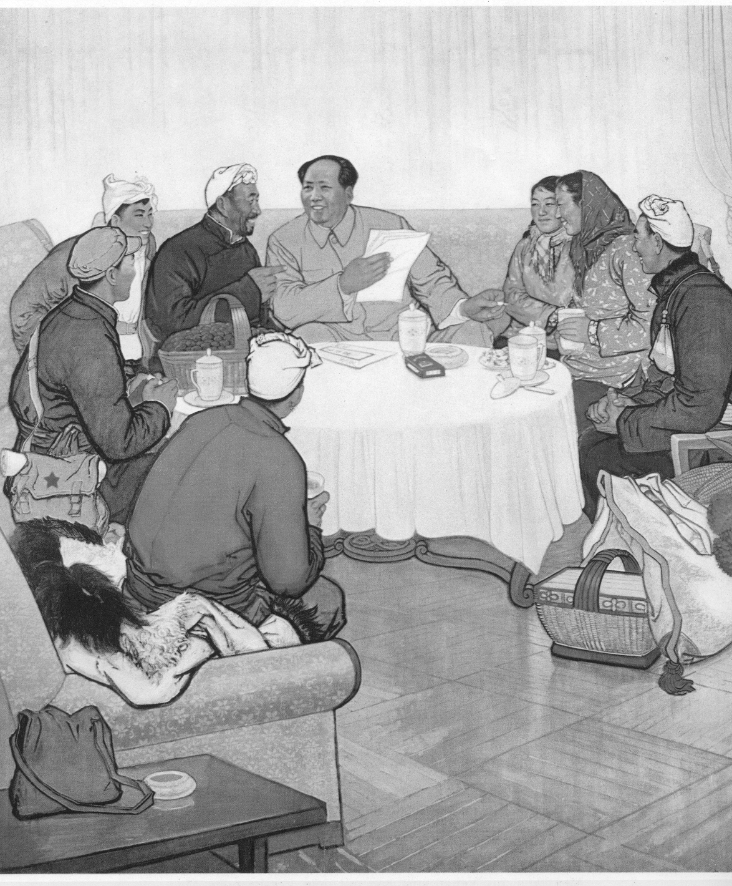

DOCUMENT SET 5
Ideas that shaped the Chinese revolution 1930s to 1990s continued

Source 2
Part (a)
(The following is an extract from an article published in September 1976 in a Taiwan newspaper, Central Daily News.)

For copyright reasons this extract cannot be reproduced in the online version of this document.
After the CCP's illegal occupation of the Chinese mainland in 1949, Mao Zedong, by using the excuse of a 'proletarian dictatorship' conducted a systematic campaign of murdering the Chinese people. He murdered no less than 60 million between 1949 and 1976. During his whole career that covered a period of fifty years, the number of people who had died because of his rebellion and violence came closer to 100 million. No one, not even Hitler or Stalin, could match him in bloodthirstiness.

Part(b)
(This short extract is taken from Mao: The People's Emperor, written by Dick Wilson and published in 1979.)

For copyright reasons this extract cannot be reproduced in the online version of this document.
His weakness was his inability to work for long with anybody who had genuine self confidence in his own judgment and would not change his ideas, merely because Mao told him to do so. He became sick of such colleagues and sometimes vindictive in his personal attitudes towards them. As Chairman he must have ultimate responsibility for the millions of deaths in China's class war... but [his] tyranny lay not in excessive personal cruelty leading to deaths or imprisonment of colleagues but in his inability to work with men of real talent.

DOCUMENT SET 6
Ideas that shaped the Cold War in Europe 1940s–1990s

Source 1
(A Soviet cartoon on the Marshall Plan in 1948 with captions translated from the Russian.)

For copyright reasons this image cannot be reproduced in the online version of this document.

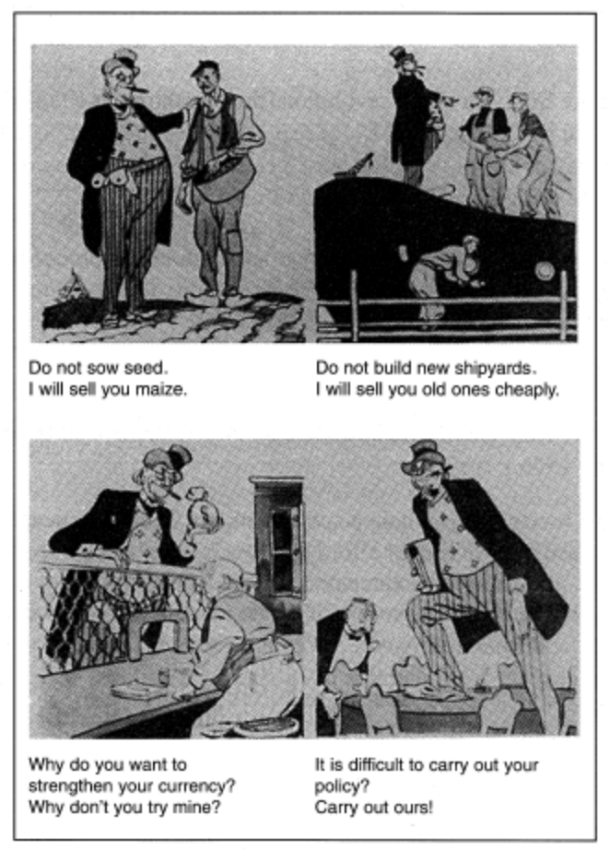

DOCUMENT SET 6
Ideas that shaped the Cold War in Europe 1940s–1990s continued

Source 2
(The following extract is from an article by Diane Kunz entitled The Marshall Plan Reconsidered and published in the journal Foreign Affairs May/June 1997.)

The Marshall Plan served as the economic and political foundation for the Western alliance that waged the Cold War. It allowed the United States gradually to engage itself in the bipolar confrontation by first committing money, not blood. After its initial subscription of dollars, the United States backed up its investment with military force, protecting Berlin against the Soviet blockade and forming the North Atlantic Treaty Organization, the first permanent military alliance in the nation's history. By providing the seed money for the recovery of Western Europe, the Marshall Plan transformed its beneficiaries from poverty cases into partners. During the quarter-century after 1948, Western Europe recorded its highest economic growth ever. This miraculous progress — indeed, the German recovery was known as the wirtschaftwunder, or economic miracle — muted the communist sirens on the eastern side of the Oder-Neisse line. Financial recovery and political stability went hand in hand; and military security soon followed.

Thanks to the Marshall Plan, Western Europe could emulate the United States, giving its citizens butter for the good life while not stinting on the guns that would protect that prosperity. The United States and its team had the recipe; the Soviet Union and its Warsaw Pact partners did not, for they lacked the economic and political freedom needed to replicate the winning amalgam.

DOCUMENT SET 7
Ideas that shaped conflict in the Middle East 1940s–1990s

Source 1

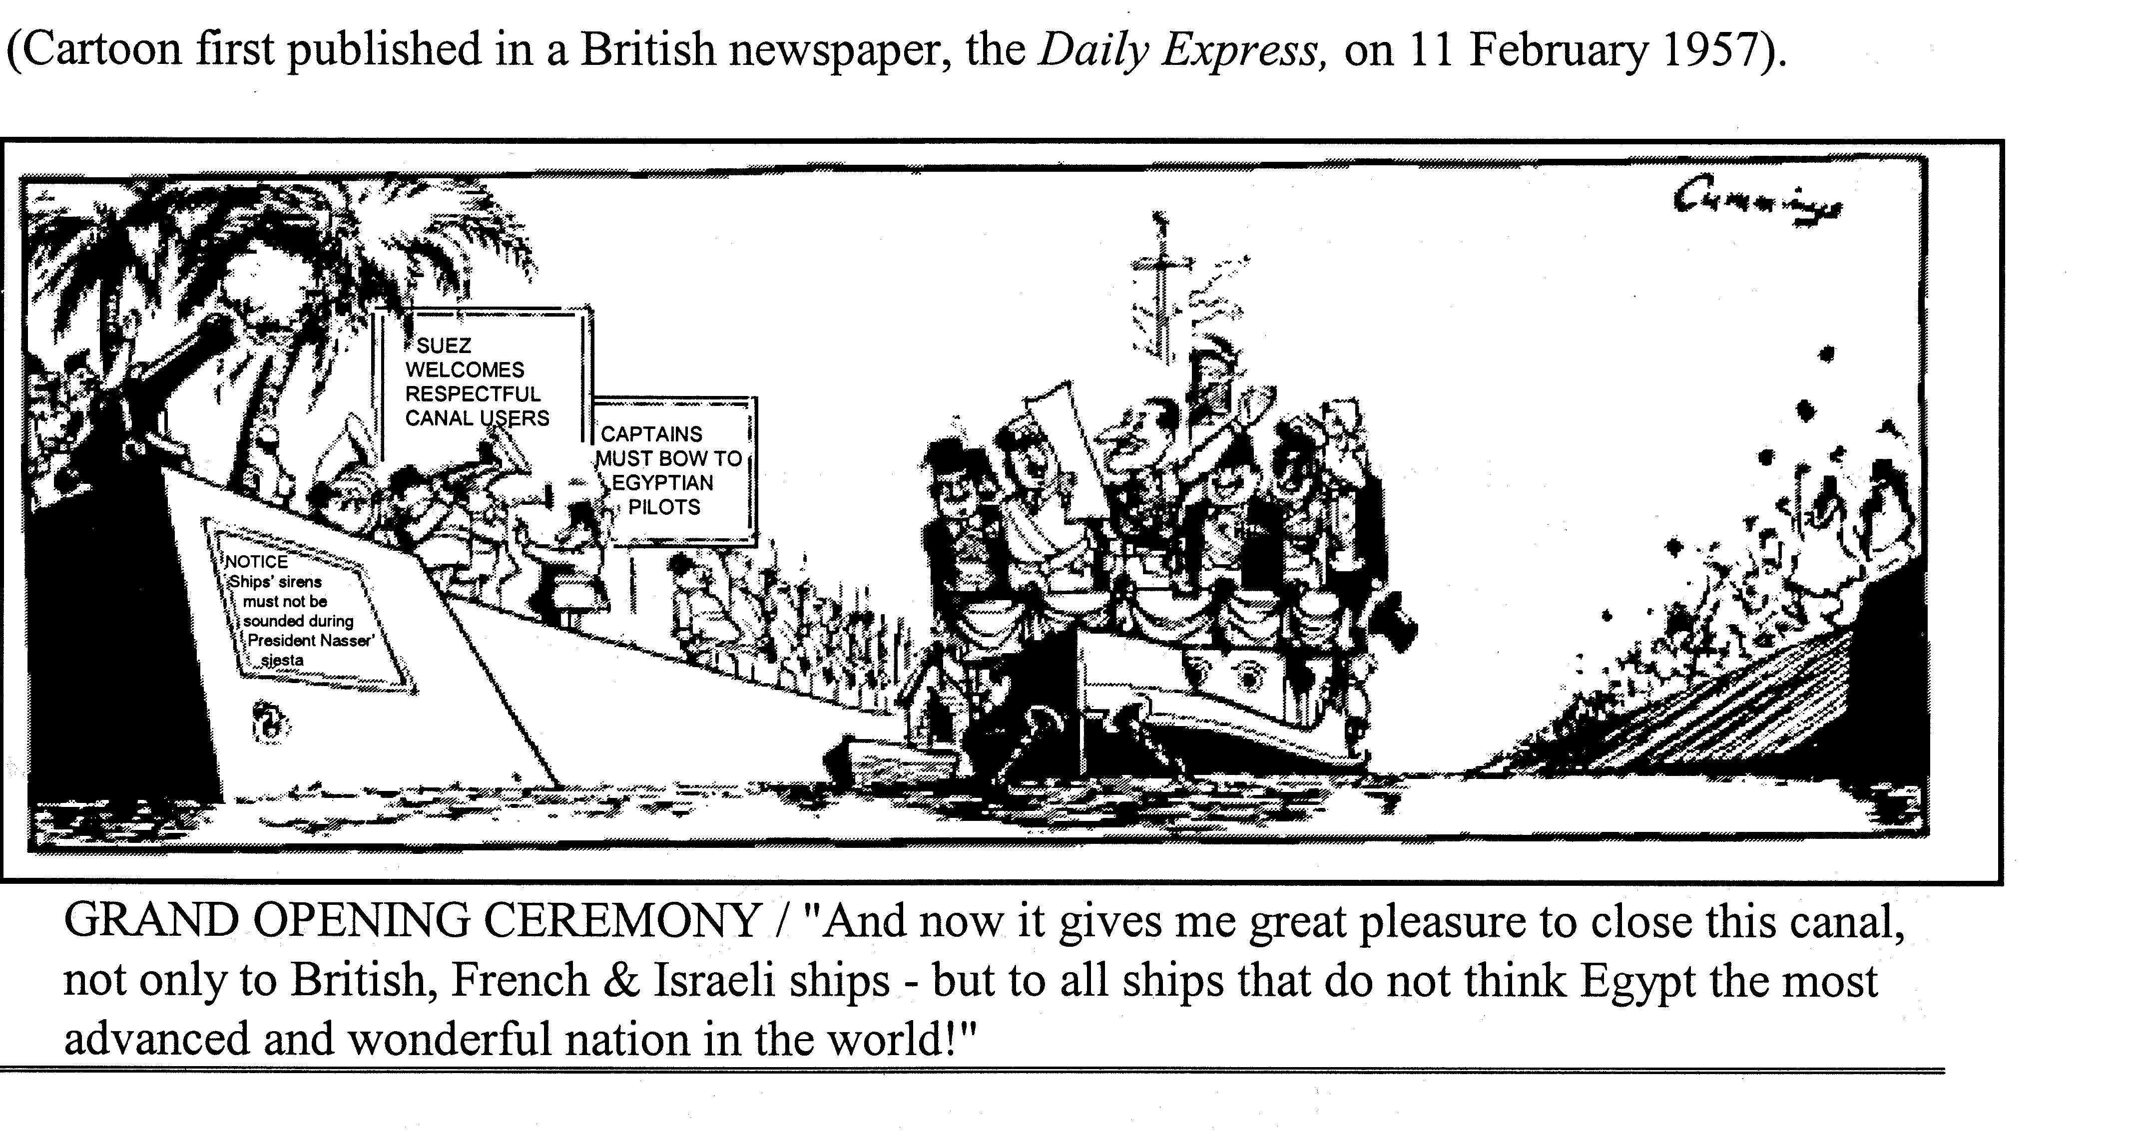

Source 2
(The following extract is from Cutting the Lion’s Tail by the Egyptian historian Mohammed Heikal and published in 1986.)

News of the ultimatum was received with astonishment bordering on disbelief. Britain and France’s collusion with Israel was now staring us in the face, but this a possibility which had been discounted, because it was assumed that, however determined on a war Eden might be, he would have some consideration for his friends in Iraq and other Baghdad Pact countries, and for British prestige and interests in the Middle East, all of which would be irreparably damaged if he committed the one unforgivable sin – combining with Israel to attack an Arab country. Nasser found the whole situation made no sense at all – it was in fact, quite mad..

In retrospect, a clash of arms between the British, who had left Egypt so reluctantly after an occupation lasting seventy years, and the forces of Arab nationalism, which Nasser came to personify, can be seen to have been inevitable.

ACKNOWLEDGEMENTS

DOCUMENT SET 1—AUSTRALIA 1800s–1920s

Source 1: Studies of Society and Environment. (1997). 1(97), p. 43. [Melbourne: Ryebuck Media]

Source 2: Crozier, F. (1919). The Beach at Anzac (ART24074) [Oil on canvas, 61 x 45.4cm]. Retrieved October, 2006, from Australian War Memorial website: http://www.awm.gov.au/database/collection.asp [Collections Search].

Source 3: McKinlay, B. (1988). A Century of Struggle: The ALP A Centenary History.
Blackburn, Vic.: Collins Dove, p. 57.
Claude Marquet cartoon used by permission Mitchell Library, State Library of New South Wales.

Source 4: Cohen, B. (1998). Ideals and Reality 1. Melbourne: Addison Wesley Longman, p. 93.

Source 5: Spenceley, G. (1988). The Search for Security: A Modern World History.
Melbourne: Oxford University Press, p. 225.

Source 6: Anzac legend unites generations. (1996, April 25). The West Australian.
Reproduced courtesy of The West Australian newspaper.

Source 7: Broadbent, H. (2005). Gallipoli: The Fatal Shore, Camberwell, Vic: Penguin, p 286.

DOCUMENT SET 2—AUSTRALIA 1920s–1950s

Source 1: Laidler, R., & White, S. (1991). Australia 1900–1950: Light on the Hill. Caulfield East, Vic: Edward Arnold, p. 193.

Studies. (1995). Issue 3/1995, p. 10. [Melbourne, Ryebuck Media]

Source 2: Browning, G. (1945). Kokoda Trail (ART24074) [Oil on canvas, 61 x 45.4cm]. Retrieved October, 2006, from Australian War Memorial website: http://www.awm.gov.au/database/collection.asp [Collections Search].

Source 3: Cohen, B. (1998). Ideals and Reality 1. Melbourne: Addison Wesley Longman, p. 117.
Norman Lindsay cartoon used by permission H., C. and A. Glad.

Source 4: PM John Curtin shaking hands with General Douglas MacArthur, Sydney 8 June 1943 [Photograph]. (1943). Retrieved October, 2006, from John Curtin Prime Ministerial Library website: http://john.curtin.edu.au/macarthur/graphics/00376_69l.jpg.

Source 5: Studies of Society and Environment. (2002). 3, p. 52. [Melbourne: Ryebuck Media]

Source 6: Anzac legend unites generations. (1996, April 25). The West Australian.
Reproduced courtesy of The West Australian newspaper.

Source 7: Broadbent, H. (2005). Gallipoli: The Fatal Shore. Camberwell, Vic: Penguin, p. 286.

DOCUMENT SET 3—AUSTRALIA 1950s–1990s

Source 1: Studies of Society and Environment. (2004). 2, pp. 29–30. [Melbourne: Ryebuck Media]

Source 2: Fletcher, B. (1970). Long Tan action, Vietnam, 18 August 1966 (ART40758) [Oil on canvas 152 x 175cm]. Retrieved October, 2006, from Australian War Memorial website: http://www.awm.gov.au/database/collection.asp [Collections Search].

Source 3: King, J. (1978). A Cartoon History of Australia. Adelaide: Savvas Publishing, p. 404.

Source 4: Moore, D. (1988). President Johnson and Prime Minister Holt at Canberra Airport—1966 [Photograph]. In J. Rickard, Australia: A Cultural History (p. 214). London: Longman. (Photograph taken 1966)
Photograph © Estate of David Moore.

Source 5: Studies of Society and Environment. (2004). 3, p. 24. [Melbourne: Ryebuck Media]

Source 6: Anzac legend unites generations. (1996, April 25). The West Australian.
Reproduced courtesy of The West Australian newspaper.

Source 7: Broadbent, H. (2005). Gallipoli: The Fatal Shore. Camberwell, Vic: Penguin, p 286.

DOCUMENT SET 4—IDEAS THAT SHAPED THE RUSSIAN REVOLUTION

Source 1: Morcombe, M., & Fielding, M. (1998). Russia in Revolution: The Spirit of Change. Roseville, NSW: McGraw-Hill, p.86.

Source 2: Pipes, R. (1995). Three Whys of the Russian Revolution. Sydney: Random House, pp. 42–43.

DOCUMENT SET 5—IDEAS THAT SHAPED THE CHINESE REVOLUTION
Source 1: Chinese Paintings: A New Series. (1977). Peking: Foreign Languages Press.

Source 2: Green, J. (1989). China. Oxford: Oxford University Press, p. 67.

DOCUMENT SET 6—IDEAS THAT SHAPED THE COLD WAR IN EUROPE

Source 1: Desailly, R., Stapleton, P., & Lewis, R. (1991). Conflict in the Modern World. Milton, Qld: Jacaranda Press, p.181.

Source 2: Kunz, D.B. (1997, May/June). Marshall Plan Commemorative Section: The Marshall Plan Reconsidered: A Complex of Motives. Foreign Affairs. Retrieved July, 2007, from http://www.foreignaffairs.org/19970501faessay3822/diane-b-kunz/marshall-plan-commemorative-section-the-marshall-plan-reconsidered-a-complex-of-motives.html.

DOCUMENT SET 7—IDEAS THAT SHAPED THE CONFLICT IN THE MIDDLE EAST

Source 1: Cummings, M. (1957, February 11). Grand opening ceremony [Cartoon]. Daily Express.

Source 2: Heikal, M. (1986). Cutting the Lion’s Tail. London: Corgi Press.
Published by the Curriculum Council of Western Australia
27 Walters Drive
OSBORNE PARK WA 6017

